install xampp on windows or install mysql in linux.

the following solution is for windows only. start xampp and start mysql first of all. Then from the CLI run these command

$ pip install pymysql

$ pip install mysql-python

Then Copy and past these 2 line in __init__.py file. please past this in the __init__.py which is inside the project folder not in the app folder.

import pymysql

pymysql.install_as_MySQLdb()

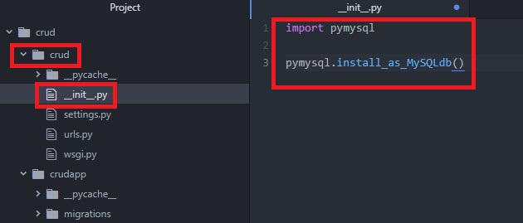

go to settings.py file and change thise line like this

DATABASES = {

'default': {

'ENGINE': 'django.db.backends.mysql',

# MySQL database host ip.

'HOST': '127.0.0.1',

# port number.

'PORT': '3306',

# database name.

'NAME': 'django',

# user name.

'USER': 'root',

# password

'PASSWORD': '',

# connect options

'OPTIONS': {'init_command': "SET sql_mode='STRICT_TRANS_TABLES'",},

}

}

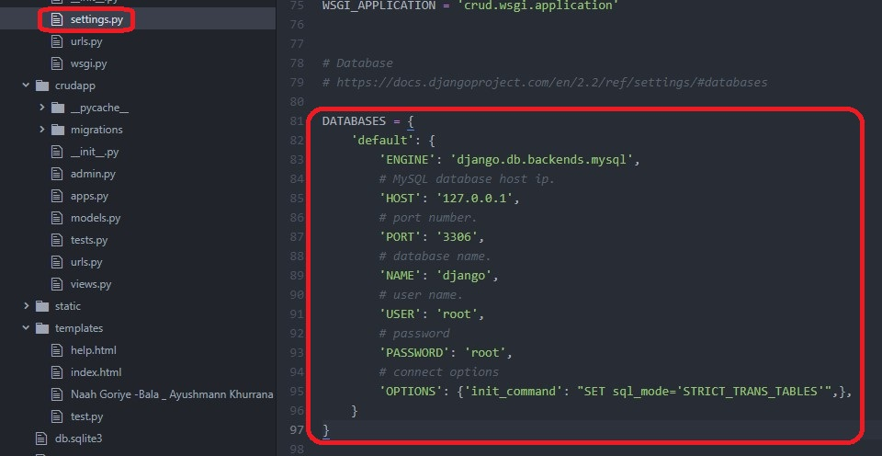

Now go to <http://localhost/phpmyadmin> and create a database name Django

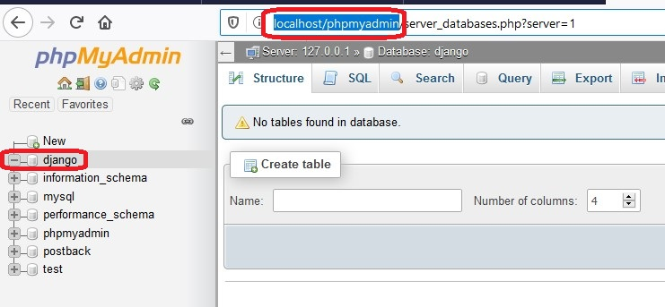

and last step you need to migrate database.

python manage.py migrate

